 | 16.1.7 Editors - Dope Sheet - Key Menu
Table of content
Dopesheet Editor - Key Menu 1
Transform 1
Grab/Move 1
Extend 1
Slide 2
Scale 2
Snap 2
Mirror 2
Insert Keyframes 2
Jump to Keyframes 2
Copy Keyframes 2
Paste Keyframes 2
Paste Flipped 2
Duplicate 2
Delete Keyframes 2
Delete Breakdowns 2
Easing Mode 3
Clean Keyframes 3
Clean Channels 3
Sample Keyframes 3

Dopesheet Editor - Key Menu
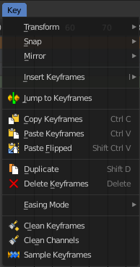
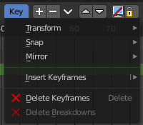
The key menu contains functionality to manage the keyframes.
The menu exist in all modes. In Grease Pencil mode it contains not so much functionality.
The grease pencil object is a special object in this regards. It can have keyframes at an object level. And keyframes at a stroke level, which the grease pencil mode is meant for.

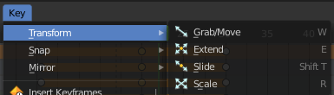
Transform

Grab/Move
Moves the selected keyframe(s).

Extend
Moves the last keyframes of the selection.

Slide
Slides a selected keyframe between two other keyframes.

Scale
Scales the selected keyframes. You need to have more than one keyframe selected.

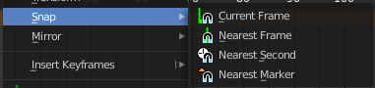
Snap
Snaps the selected keyframes by the chosen method.

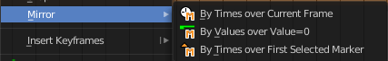
Mirror
Flips the selected keyframes over the current frame position.

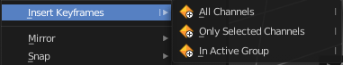
Insert Keyframes
Choose a method how to insert a new keyframe at the current frame position.

Jump to Keyframes
Sets the frame marker at the average position of the currently selected keyframes.

Copy Keyframes
Copy selected keyframes.

Paste Keyframes
Pastes copied keyframes.

Paste Flipped
Pastes copied keyframes, but flipped.

Duplicate
Duplicate selected keyframes.

Delete Keyframes
Deletes selected keyframes.

Delete Breakdowns
Remove breakdown frames generated by interpolating between two grease pencil frames.

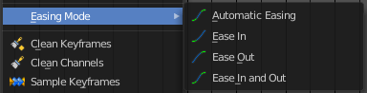
Easing Mode
Choose between different easing modes for the selected keyframes. Easing is a method to fade in and out curves.

Clean Keyframes
Simplify FCurces by deleting keyframes that are close to each other in all channels

Clean Channels
Simplify FCurces by deleting keyframes that are close to each other in selected channels.

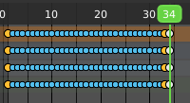
Sample Keyframes
Adds keyframes at every unit between the selected keyframes.

